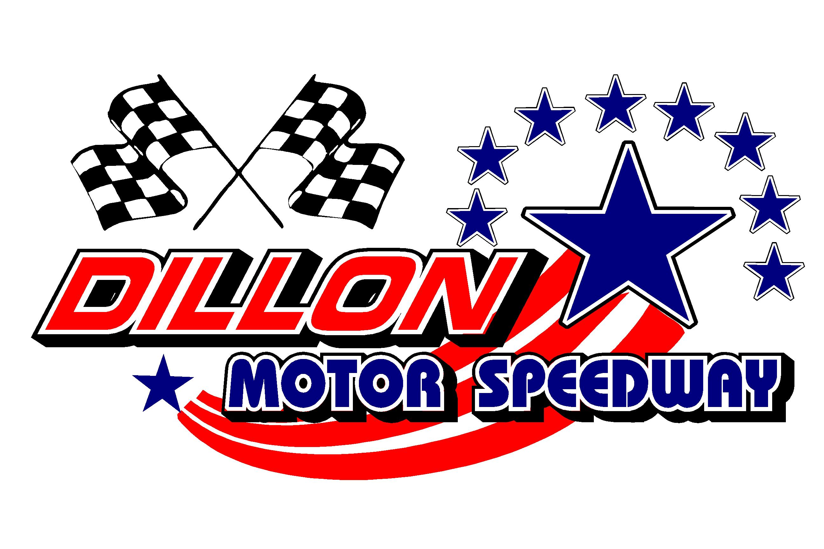

16th Annual New Years BASH January 2-4, 2026
Presented by AirPure Technologies
Drivers Pre Enter For Provisional Starting, Parking & Bonus Money

Driver’s Name (print) ______________________________________Date_________________

Street __________________________ City ______________________ State _______ Zip_______

Cell Phone_______________________ Email_________________________________________

Facebook______________________________Legends Class_____________________________

Home Track__________________________2025 Wins___________________________________

Championships and Awards (Continue on Back)_______________________________________

______________________________________________________________________________

Car Number (Up to 3 digits) 1st __________ Car Colors______________________Car Type______________

_____ Circle the Class you will Race In_________________________
$2000 To Win STREET STOCK (Sat & Sun)- $100

$800 To Win (MiniStock 4 Cylinder (Sun)- $40

$2000 To Win CHALLENGER (Sat)- $75

$500 To Win UCAR / Pure Stock (Fri) -$40
$500 To Win Legends (Sat & Sun) $30

$1000 To Win Dirt Cars on Asphalt $NC

$1000 To Win Crown Vic (Sat)- $40
Make Sure You Send in Your Pre-Enter for this EVENT
No Money Required To Be Sent! Pay at Sign In Window the Day of the Race
Email Form: chrisnealwebproductions@gmail.com
or US Mail to: Dillon Motor Speedway P.O. Box 148 Dillon, SC 29536
Drivers Pre Enter For Provisional, Parking, Bonus Money & Payout 16th Annual New Years BASH January 2-4th 2026
The New Years BASH is an annual race any car maybe able to race by adding weight and/or restrictor plate. Tech man decision is final.

